Task 1

* MOV AX 3d ;syntax error mov ax,3d
* MOV 23, AX ;syntax error mov ax,23
* MOV CX, CH ;no error
* MOVE AX, 1h ;incorrect statement mov ax,1h
* ADD 2, CX ; syntax error add cx,2
* ADD 3, 6 ;No destination
* INC AX, 2 ;invalid syntax only increase by 1

Task2

INCLUDE Irvine32.inc

.code

main PROC

mov eax, 'p'

mov ebx, 'a'

mov ecx, 'r'

call DumpRegs

exit

main ENDP

END main

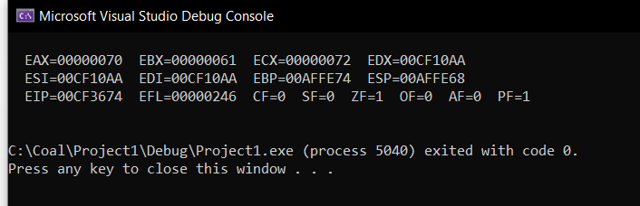

Task3

INCLUDE Irvine32.inc

.data

varB BYTE +10

varW SWORD -150

varD DWORD 600

.code

main PROC

movzx eax, varB

call WriteInt

call crlf

movsx eax, varW

call WriteInt

call crlf

mov eax, varD

call WriteInt

call crlf

exit

main ENDP

END main

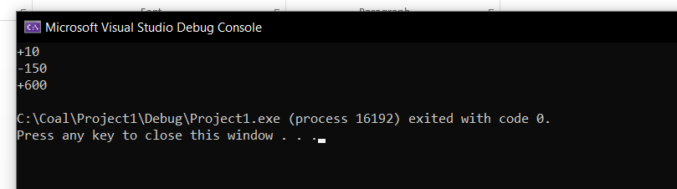

Task 4

1

INCLUDE Irvine32.inc

.data

; EAX = 89 + 75Fh – 46o – 28 + 1101b

.code

main PROC

mov eax,0

mov eax,89

add eax,75Fh

sub eax,46o

sub eax,28

add eax,1101b

call Dumpregs

exit

main ENDP

END main

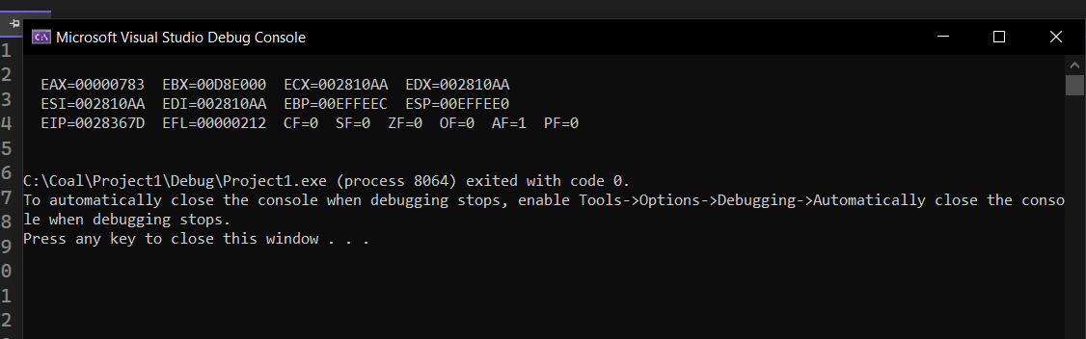

2

INCLUDE Irvine32.inc

.data

;EAX = val1 + val2 – 654h + val3

val1 DWORD 25h

val2 BYTE 36o

val3 WORD 20d

.code

main PROC

mov eax,0

mov eax,val1

movzx ebx,val2

add eax,ebx

mov ebx,654h

sub eax,ebx

movzx ebx,val3

add eax,ebx

call Dumpregs

exit

main ENDP

END main

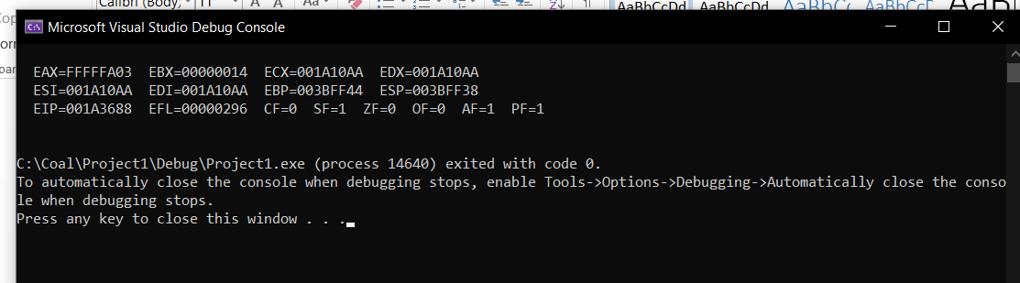

Task5

INCLUDE Irvine32.inc

.data

SecondsInDay equ 24\*60\*60

.code

main PROC

mov eax,0

mov eax,SecondsInDay

call WriteDec

exit

main ENDP

END main

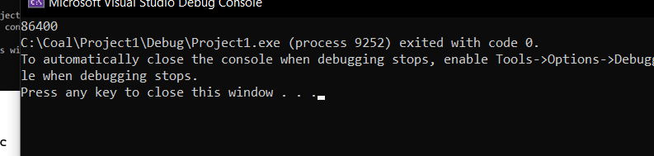

Task 6

INCLUDE Irvine32.inc

.data

A word 0FF10h

B word 0E10Bh,

.code

main PROC

movzx eax,A

movzx ebx,B

call DumpRegs

call Crlf

xchg eax,ebx

call DumpRegs

exit

main ENDP

END main

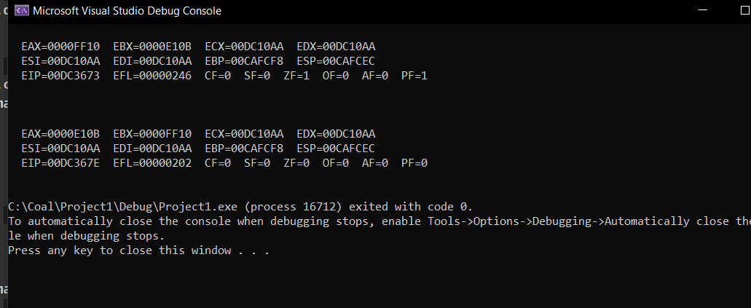

Task 7

INCLUDE Irvine32.inc

.data

val1 BYTE 10h

val2 WORD 8000h

val3 DWORD 0FFFFh

val4 WORD 7FFFh

.code

main PROC

call DumpRegs

movzx eax,val2

inc eax

call DumpRegs

movzx eax, val1

movzx ebx,val2

sub eax,ebx

call DumpRegs

movzx eax, val4

movzx ebx,val2

sub eax,ebx

call DumpRegs

exit

main ENDP

END main

